

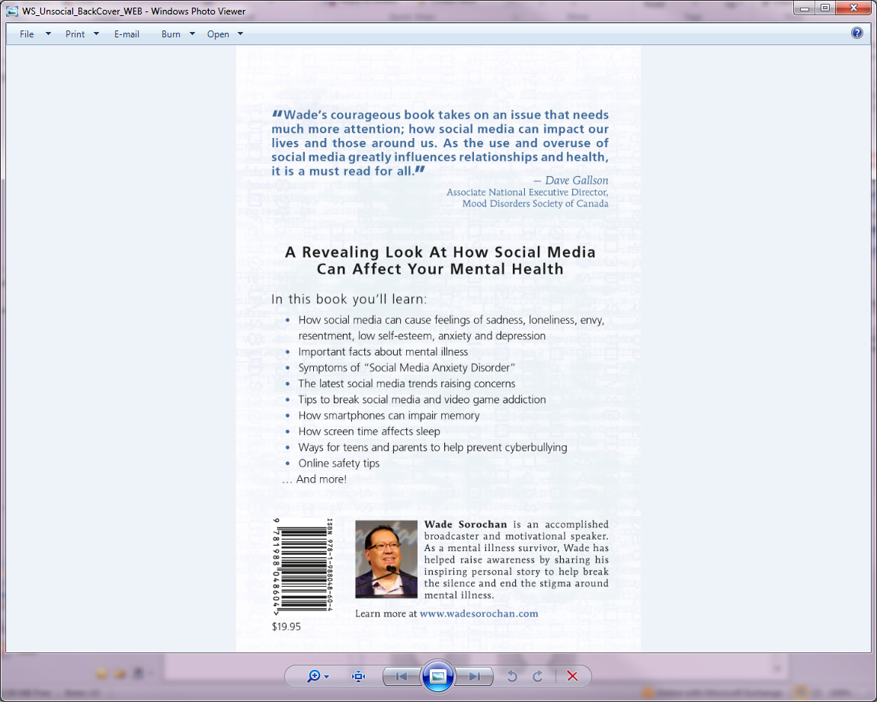

**Based on the Popular Book**

Media personality, mental health advocate and author, Wade Sorochan’s engaging and humorous presentation reveals how social media can cause feelings of sadness, loneliness, envy, resentment, low self-esteem, and anxiety and depression.

* Important facts about mental illness
* Symptoms of “Social Media Anxiety Disorder”
* The latest social media trends raising concerns
* Tips for teens to help prevent cyberbullying
* How screen time affects sleep
* How smartphones can impair memory
* Tips to break social media and video game addiction
* Practicing online safety…And more!

**Space is limited - Registration is encouraged!**

**Email** [**info@spinbrandon.ca**](mailto:info@spinbrandon.ca) **to register for either session or call 204-578-2599**

**call 204-578-2599**

With this information, youth will become awaree negative effects of social media, and control the attraction before it turns into an addiction, which could cause serious mental health issues.



Presents

Thursday March 16th, 2017

7:00–9:00pm open to the public/youth

Friday March 17th, 2017

9:00 – 11:30am service providers

City of Brandon Youth Centre

A.R. McDiarmid Complex

East door – 638 Princess Ave.

