Reach Out - SPIN Recommends Five Ways to Get Involved:

- Raise awareness. Talk to your family, friends, and colleagues about suicide prevention. Talk without judgement, we can break down stigma and raise awareness about the services and resources available for those in need. Enhance knowledge of local crisis support and resources, and reach out if you are experiencing emotional distress.
- Westman Crisis Services 1-888-379-7699
- Manitoba Farm, Rural & Northern Support Services 1-866-367-3276
- Manitoba Suicide Line 1-877-435-7170
- Resource List www.spinbrandon.ca

- Participate: Become involved in activities that support mental well-being and build resiliency. Strengthen your own personal coping strategies, build connections with others, and be alert to others in need. Let’s build a healthy community!

- Learn More: Do you have questions around suicide, its causes, and want to know how it may be prevented through open and honest discussion? Consider taking one of the following programs:
- Mental Health First Aid – a 2-day workshop that assists participants recognizing and understanding mental illness, and how to provide the initial help to someone experiencing a mental health problem ($75)
- SafeTALK (Suicide Alertness for Everyone) – 3 hour workshop that teaches you how to identify those having thoughts of suicide and get them connect with Keep Safe resources. (no cost)
- ASIST (Applied Suicide Intervention Skills Training) – 2-day workshop of practical skills for individuals who want to feel more comfortable and competent in helping to prevent the immediate risk of suicide ($100)
- For More Information or to Register for anyone of these programs contact Kaila Derhak at 204-578-2490 or email: kderhak@pmh-mb.ca
- Donate: Do you want to help us enhance mental health resources and support local suicide prevention initiatives? Donations may be made to:
- BRHC Foundation – SPIN
150 McTavish Avenue East
Brandon, MB R7A 2B3
Together we can make our community “Suicide-Safer”
- 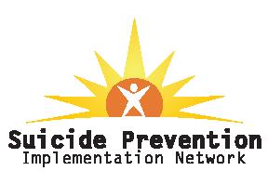Volunteer: Would you like to get more involved, become a SPIN member, or help in one of the many SPIN initiatives? Contact any SPIN member or Chairperson John Jackson at 204-729-3858.

