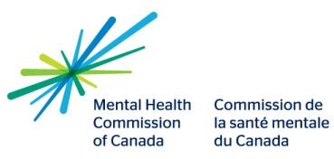
For Adults Who Interact with Youth

Mental Health First Aid (MHFA) Canada For Adults who Interact with Youth is a two-day, 14-hour workshop that teaches first aid skills to adults, to help youth developing a mental health problem or is experiencing a mental health crisis.
Who should take MHFA?
Anyone can benefit from MFHA. It is open to all members of the general public, families affected by mental illness, teachers, health service providers, emergency workers, frontline workers, volunteers, managers, employers or community groups.

Participants will learn:
- To recognize signs and symptoms of common mental health problems and crisis situations
- The basic actions for mental health first aid
- Information about effective interventions and treatments
- How to access help and resources
REGISTRATION FROM
Name:
Organization: |  |  |  |  | Occupation:
Phone: |  |  |  |  | Email:
Enter Your Course Date |  |  |  |  |  |  | Basic |  | Youth
Workshop Fee: $75.00 |  |  | Please Make Cheques Payable to: Prairie Mountain Health
 |  |  | Internal Transfer Code:
*Workshop fee and registration form must be received and processed one week prior to requested course dates to confirm participation. A minimum of 14 participants required to hold course. A maximum of 20 participants per course.
*Registration fee is non-refundable unless cancellation is made 5 business days prior to the workshop?

In completing this registration form, I understand that participation for the entire two days from 8:30 to 4:30 is mandatory for certification. If for any reason I am unable to attend all sessions, I will be required to make arrangements to complete the two days in their entirety to be eligible for certification.

Signature: ______________________________________________________________ Date: _____________________
Please return to: |  | Kaila Derhak, B9 800 Rosser Ave, Brandon, MB, R7A 6N5  kderhak@pmh-mb.ca  Ph; 204-578-2490 Fax: 204-571-2951

